P.R.A.Y.

People, Religion And You

Computer Science / ITS Project 1 & 2 | CMPT 475/477 Capping Project

Presented By Riley Stadel, Griffin Wiles, Dan Schroeder, Ryan Demayo,

Christian Gorokhovsky

# Table of Contents

**Table of Contents** **1**

**Summary of Relevant Facts** **2**

**Software Project Analysis** **4**

**Use case diagram and documentation** **5**

**Activity diagrams and documentation** **6**

**Software Project Design** **10**

**User Interface Navigation** **11**

**Infrastructure specifications** **17**

**Prototype Deployment Instructions** **18**

**Cost Analysis** **19**

**Revised project plan** **20**

**Social Media and Ethics** **23**

# Summary of Relevant Facts

Social media is undeniably a juggernaut of influence that has permeated the public consciousness exponentially within the past decade. It has become a great means through which information, factual or otherwise spreads. It has encapsulated what it means to be relevant in today’s society. The benevolence of such an influence is a point of contention amongst those who believe information dissemination and social interaction are above all else, and those who note the malicious implications of everyone being connected always. Such an interconnected and unmoderated network can prove to be the breeding grounds of toxicity. Unfiltered access, coupled with the pseudo-anonymity provided by the internet, has resulted in a multitude of cases which certainly bring into question the integrity of social media. It is common knowledge that by creating a layer of abstraction between individuals, these individuals will be subject to a degree of dehumanization to others. This is because face-to-face interaction is considered the most “pure” in terms of humanizing individuals, as one can see the impact of their words and actions directly and immediately. With a layer of abstraction, the impact of one's actions aren’t directly presented and thus, to a degree, every interaction over social media is subject to this effect. Some individuals use this opportunity to vent their negativity through toxic messages and posts. In an unfiltered network, this runs rampant as problem individuals see little to no repercussions for their negativity and can be inspired by the infamy to continue and perhaps even intensify their rhetoric. In lieu of a solution, social media, as it stands today, presents a generally unstructured forum, leaving those seeking support and positivity with no options in achieving their ends. This is not only a problem but also an opportunity for the emergence of a structured network geared towards maintaining a positive community revolving around support. PRAY fills the positivity vacuum. It is geared entirely towards maintaining a community of supportive individuals. This is done by many website functions that seek to filter out negative individuals and remove them from the platform. One example of such a function is the downvote filter. Each post can be voted on by an individual, receiving either a +1 or -1. If a post reaches a total score of -5, it is automatically removed. This removes the incentive for individuals to build infamy on the platform. Every post, including those who have a positive rating, are able to be reported and swiftly examined by moderators. The moderators then have the ability to delete the post or take further action against the individual. Another example would be the power that the platform gives to individuals for self-moderation. A user may delete any reply to their post for any reason. This means that users have the power to remove toxicity themselves. Within such a network, toxic individuals are near powerless, as their posts have many avenues toward removal and their comments can be removed on a whim. PRAY is a shining beacon of hope and positivity.

# Software Project Analysis

**Specification of User Requirements**

Complete documentation of functional and nonfunctional requirements (Some of this information can be taken from the case study document, client interview/questions, and faculty conversations)

**Functional Requirements**

* Ability to create account
* Ability to post prayers
* Ability to post pictures
* Ability to interact with posted prayers(comment, like, dislike, delete)
* Ability to change account settings
* Ability to follow/unfollow religions
* Ability to interact with other users directly
* Ability to edit your profile(pictures, bios)
* Ability to moderate
* Users receive notifications when one of their prayers is interacted with

**Non-Functional Requirements**

* Ability to edit a prayer
* Ability to block users

# Use case diagram and documentation

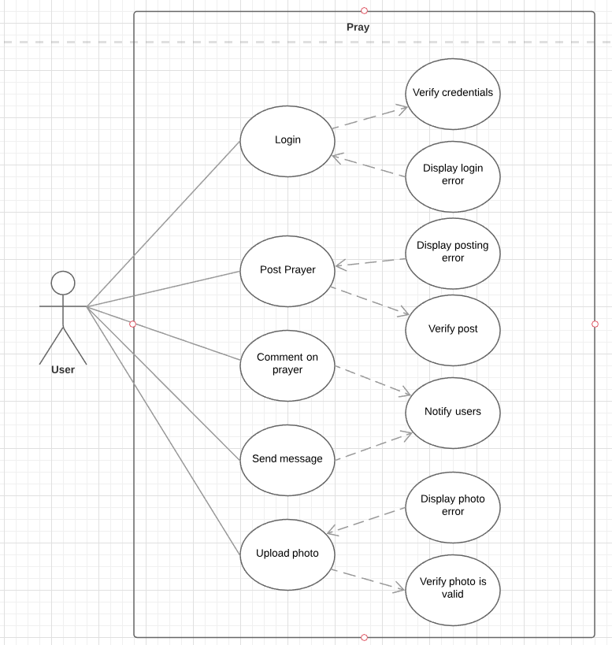

# Activity diagrams and documentation

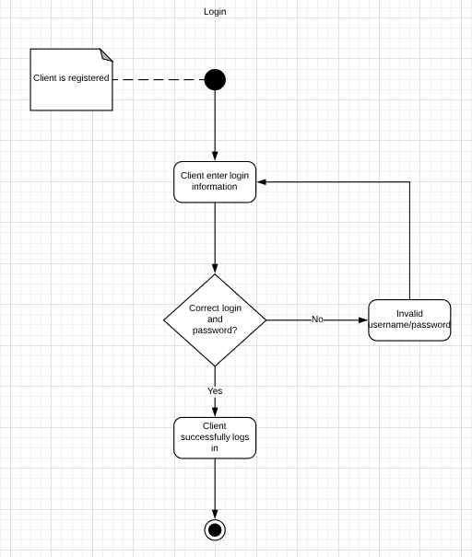

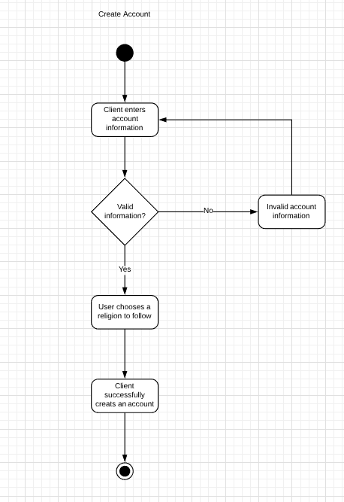

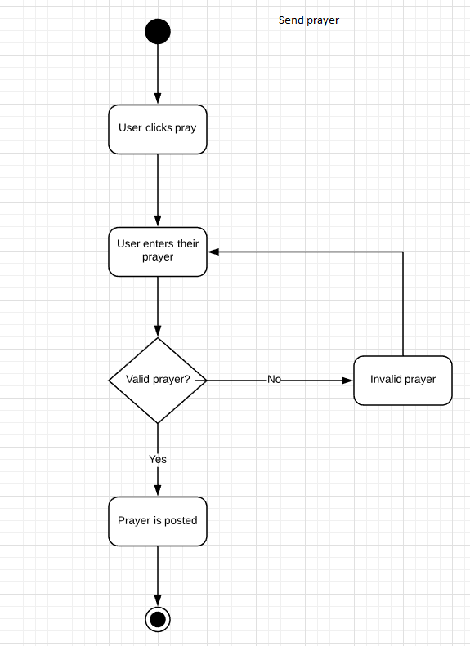

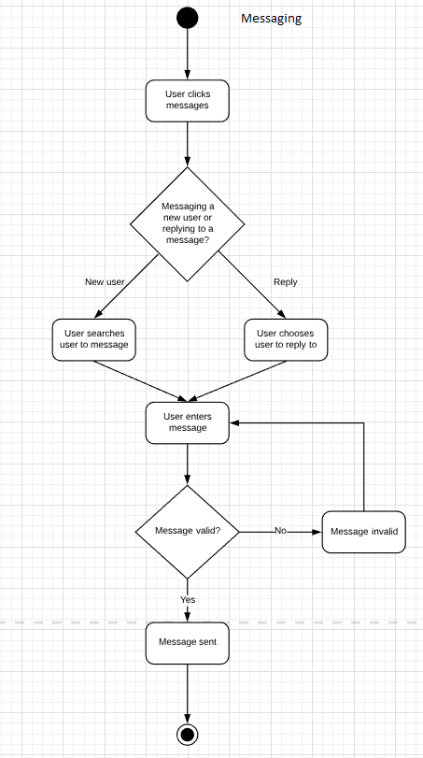

# 

# Software Project Design

Database design, model, and documentation (keys, table purposes)

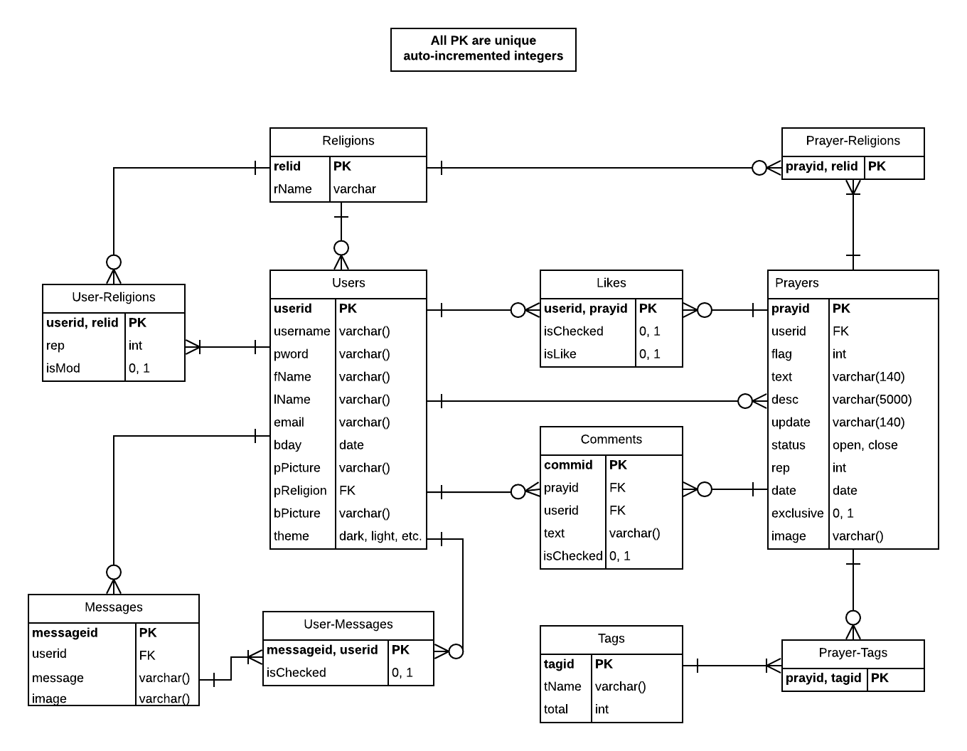

# User Interface Navigation

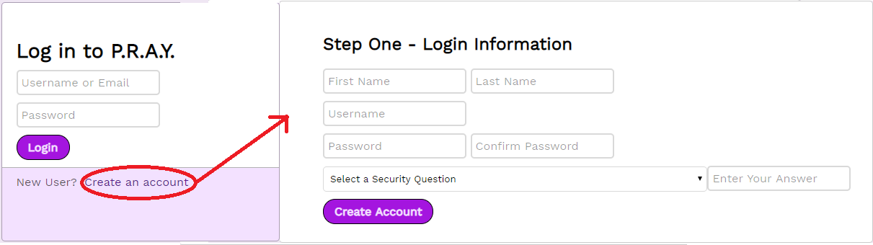

Pressing “Create an account bring the user to a page where they are prompted to enter some information to create an account on the platform. They are then prompted to select a primary religion to follow

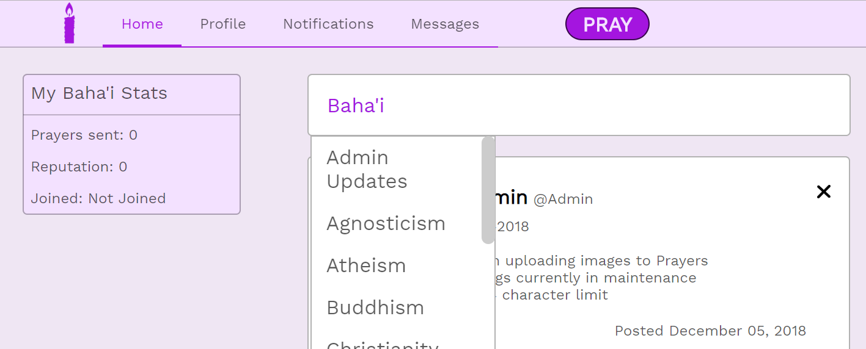

Users can click on their selected religion to change which feed is displayed.

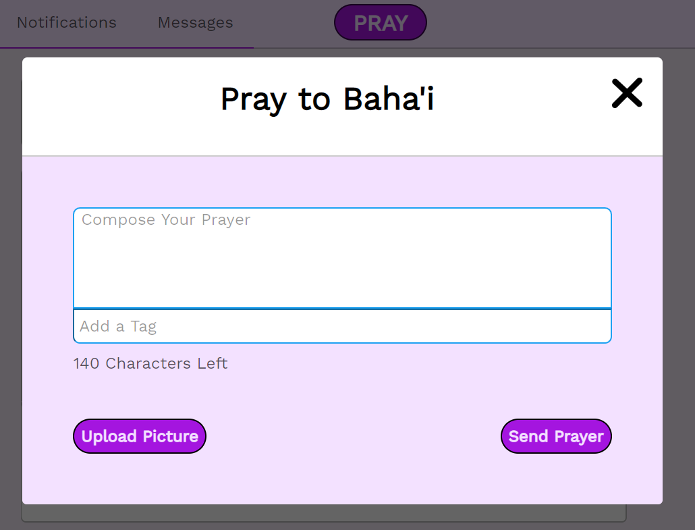

Clicking the purple “PRAY” button at the top center of the page results in a popup prompting the user to compose a prayer and add a tag for the prayer. Users are also able to upload an accompanying picture before pressing “Send Prayer” to submit it to the associated religion’s feed.

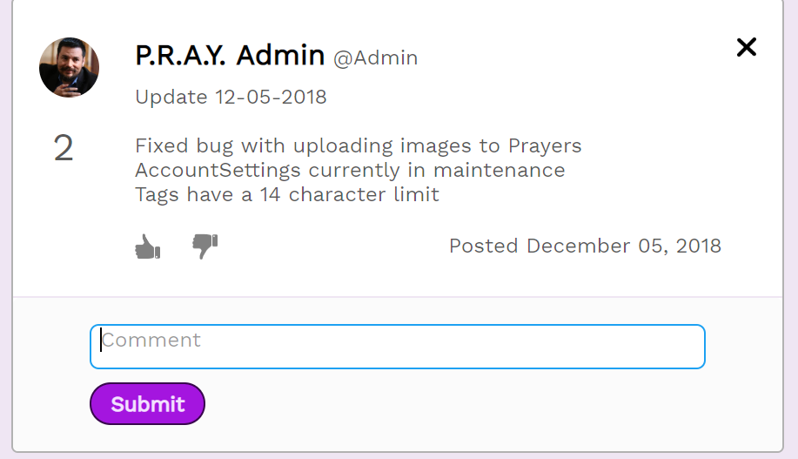

Comments can be entered by typing a comment and pressing “submit” to post the comment under a post.

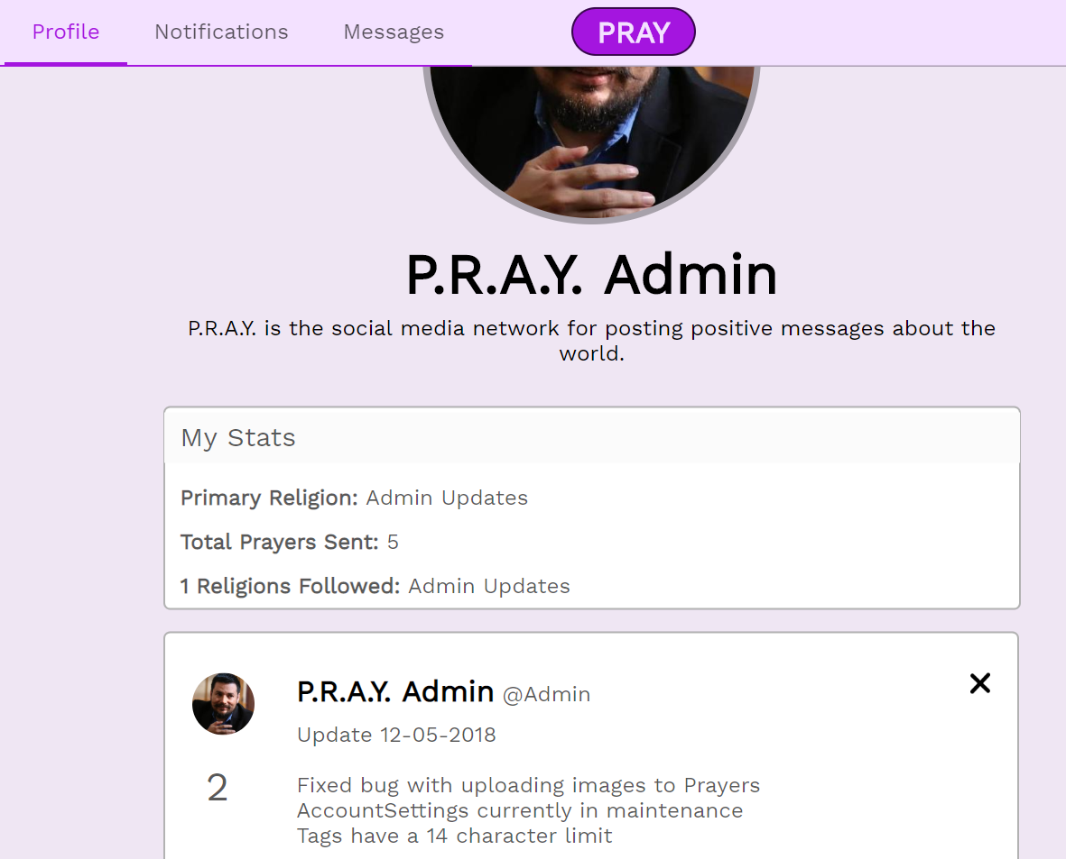

The “Profile” page can be accessed by pressing “Profile” at the top left corner. This brings up the current user’s profile page, complete with their bio, stats, and previous posts.

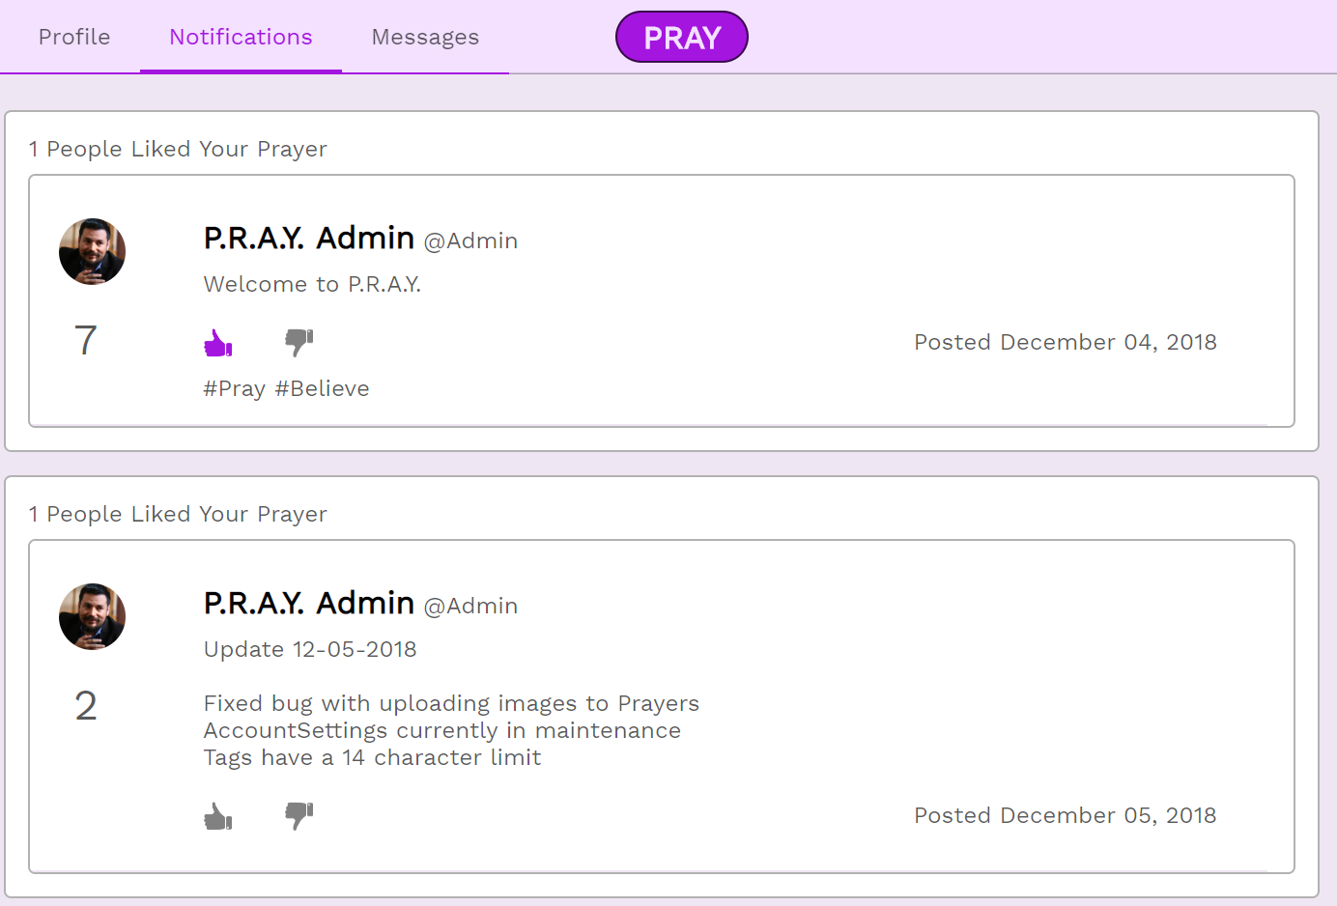

By pressing “Notifications” the user is able to see the community’s response to their prayers

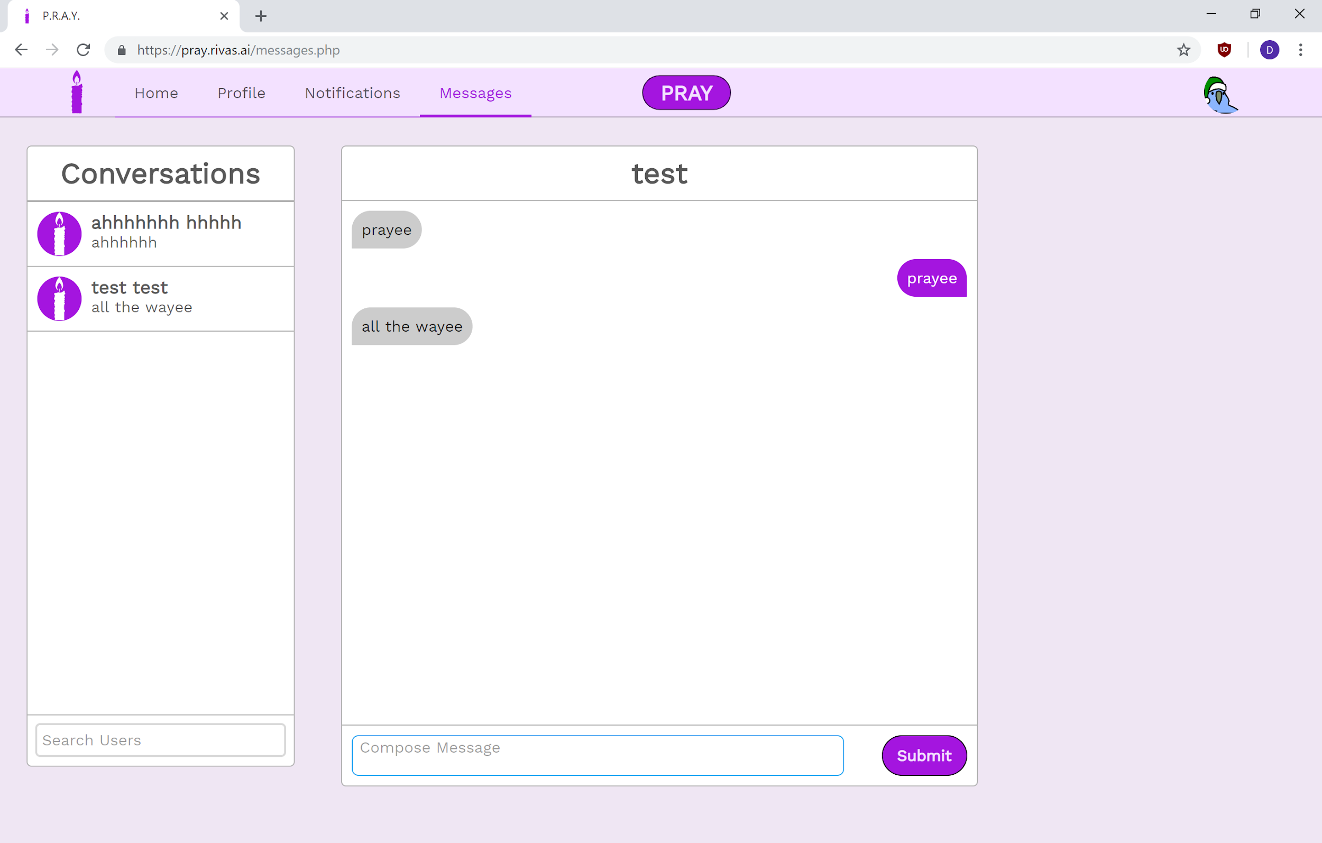

By pressing “Messages” the user is able to privately contact other users directly.

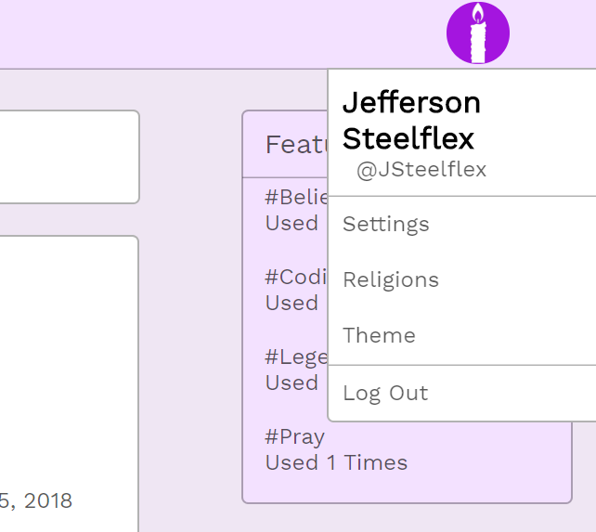

The user’s profile picture on the top right serves as a way for users to access general settings relating to their account and the site. “Theme” allows users to switch between a lighter theme and a darker theme

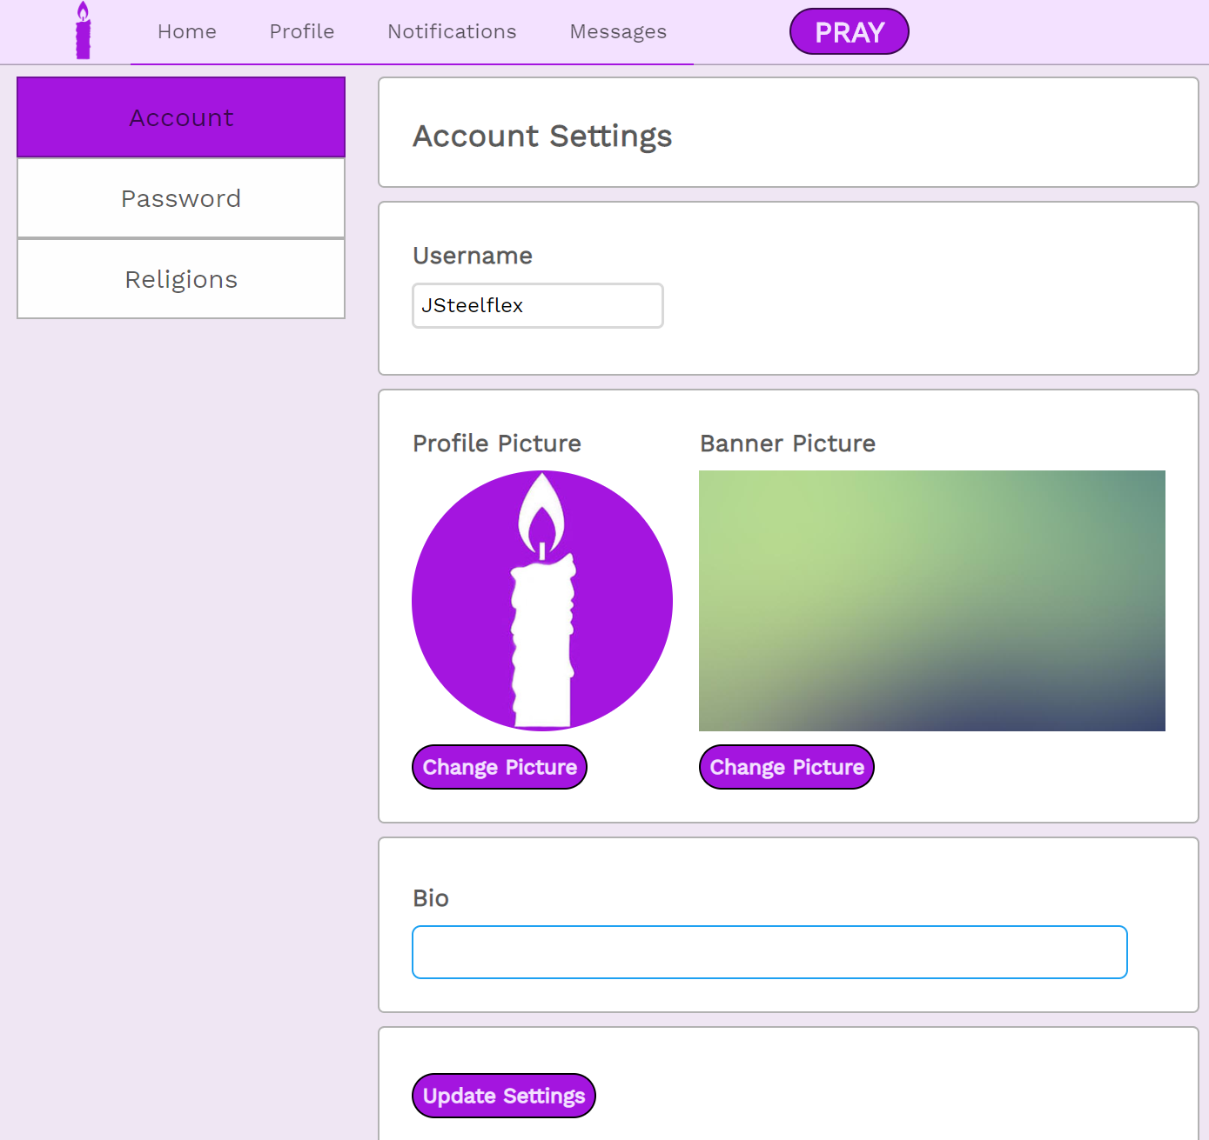

Pressing “Settings” brings the user to the account settings page. Here they are able to change their username, profile picture, banner picture, and bio. These changes are finalized by pressing “update settings”

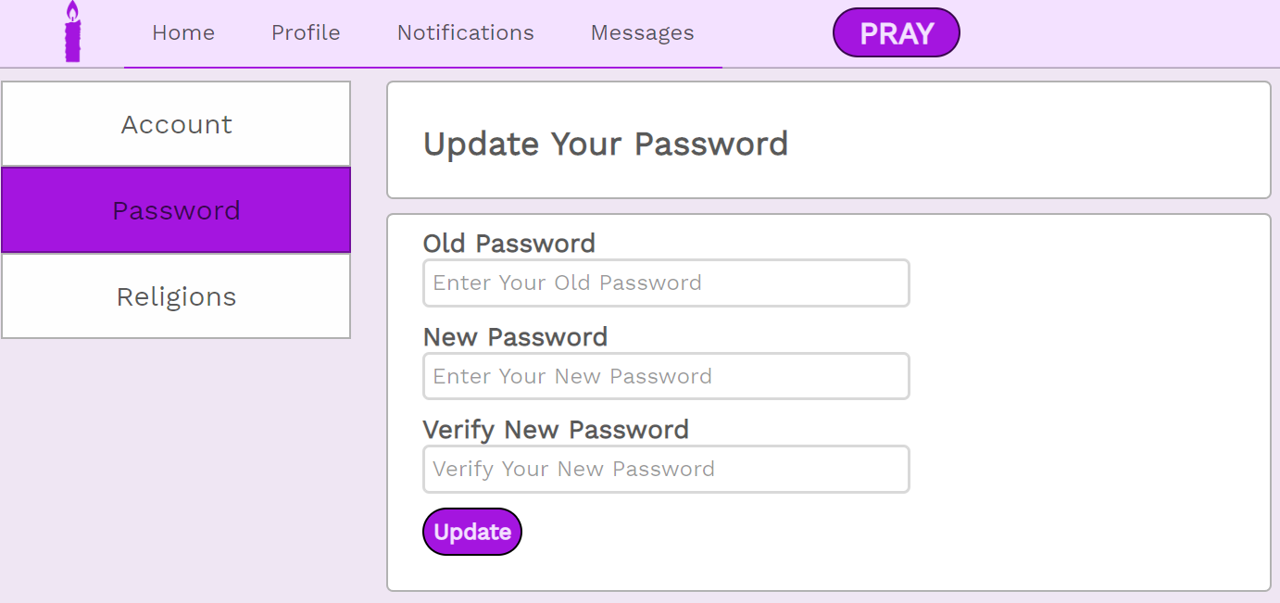

By pressing “Password” the user is brought to a page where they are able to change their password. Once Old Password, New Password, and Verify New Password are filled out, a user can press “Update” to finalize these changes.

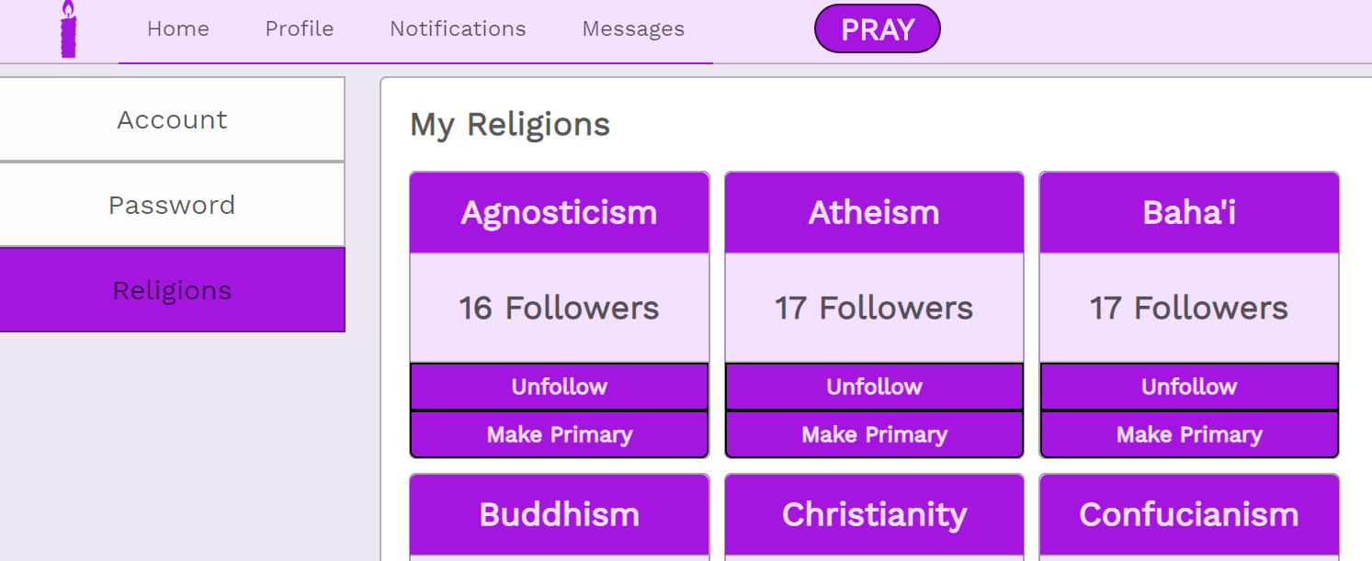

By pressing “Religions” the user is able to follow new religions, unfollow currently followed religions, and change their primary religion.

# Infrastructure specifications

1. Server Platform (for each “server” required)
   1. Physical system requirements
      1. 3 servers: Web, Database, Application, 50GB to start, 512TB in the end after switching to AWS
      2. Utilize AWS Archives for backups later on if the need arises
   2. Virtual system requirements
      1. OS to be supported - Windows, possibly create an app later on
      2. Number of images expected - 50,000 in the first year, but this number could grow depending on how popular it becomes

1. Reliability
   1. Service Level Agreements
      1. Uptime requirements - around 97% uptime
2. Recoverability
   1. Backups - Every hour, saved to a separate server
   2. Access to backups - Server Admins
   3. Storage - Everything we are storing is long term
3. Security and Privacy
   1. Database
      1. Access controls - Admins, and moderators are able to alter the database
      2. Update vs. Access - Users update when praying and editing prayers
   2. Account information
      1. User data
         1. Personal / registration - Stored in DB
      2. FERPA/Privacy considerations - Encrypted user data
   3. Admin access controls
      1. Adding new users, deleting old - Admin has the ability to remove users and prayers from the database
4. Maintenance
   1. Planned down time requirements
      1. Database maintenance - Monthly checkups to make sure everything is still in order

# Prototype Deployment Instructions

<https://github.com/RyS0315/CappingTeam14/tree/master/PSN>

The project in production can be accessed via the link: pray.rivas.ai

Test case - New User

1. Click create account, and create an account.
   1. Here you can test SQL injection checks
2. Follow a religion.
3. Post a prayer
4. Upvote/downvote the prayer
5. Post a comment
6. Delete the comment
7. Click on your profile picture in the top right and go to settings
8. In the setting page, change your profile picture
   1. Here you can see an error is thrown if the picture is too large
9. Enter a new username into the field
10. Click update settings at the bottom of the page
11. Logout

Test case - Admin

1. Go to login page
2. Login to the admin account
   1. Username is Admin
   2. Password is D0n0t@m3
3. Find a comment on a prayer, and delete it
4. Find a prayer, and delete it
5. Post a prayer with a picture
   1. An error is thrown if the picture is too large
6. Go to messages, and search for a user to message
   1. Send them a message

# Cost Analysis

$50,000 for a 25% stake in P.R.A.Y.

$10,000 - CyberSecurity Assessment - This is the average cost for a cybersecurity assessment for an entrepreneur

$15,000 - Server Upgrades and Testing - We need to upgrade our servers to account for the large number of pictures needed to support users. Each user has two pictures and our server caps out at around 500 users

$15,000 - Developer Charge - Around 750 hours of work at $20 an hour

$10,000 - Advertising Fees - $5,000 for acquiring a user base, and $5,000 for positive ads within the PRAY site

# Revised project plan

|  |  |  |  |
| --- | --- | --- | --- |
| 8/27/2018 | Project Start | Form team: make introductions; inventory skill strengths and weaknesses; forumulate and document initial roles and responsibilities (to be modified as needed later). | All |
| 8/27/2018 | Project Start | Schedule 1st team meeting - and attempt to choose recurring team meeting times that work for everyone (can be established later); establish a communications plan (ie. share emails, cell#'s, and establish how you will stay in touch) | All |
| 8/27/2018 | Project Start | Further develop this project plan (it is part of HW1) - THINK through your time management and what you will accomplish as the weeks progress. | All |
| 9/5/2018 | Team Meeting; 1st homework started | Have met at least once by the end of the day on 9/7; have started Homework #1- Work on a design, and plan where we need to start/how we proceed | All |
| 9/12/2018 | Homework #1 Due! | Meet during the week  Have HW1 done;  Have your client questionnaire finalized and be prepared to interview the client. | All |
| 9/19/2018 | Homework #2 Due | E-R diagrams complete with supporting documentation if explanation is required for anything you document in your diagrams. IT Requirements due | All |
|  | Begin Implementing Database | Begin database implementation | CS |
|  | Design Layout Finished | Designed a basic layout for what pages we will need/how they will be connected | All |
| 9/26/2018 | Homework #3 Due | Complete mock-ups (ie. wireframes) of your user interface. | All |
|  | Begin implementing design | Began coding the groundwork for the site. | CS |
|  | Finish Database implementation | Finished implementing the database | CS |
|  | Begin implementing user functionality | Created login function and verification. Created user feed. |  |
| 10/3/2018 | E-R Diagrams final, functional database | Final Project Plan - updated with all input from instructor  Final UML Diagrams |  |
|  | Setup VM | This week we finished setting up our VM | Griffin |
| 10/10/2018 | Database design draft | Draft database design | All |
|  | Create Admin page and admin functionality | Created the page for admins that allows them to view account information and manipulate that information |  |
| 10/17/2018 | Mid-semester peer reviews due | Complete initial (ie. first pass feedback) peer reviews | All |
|  | Homework 4 Due/ Early Demo | Be prepared to present and early demo in front of the class; Test for bugs and plan what will be presented. | All |
|  | Finish Create Account Function |  | Riley |
| 10/24/2018 | Responsive Design and profile page |  | Griffin |
|  | Icons and formatting |  | Dan |
|  | Picture pop out view |  | Riley |
| 10/31/2018 | Prayer Timestamps | Display time published on prayers |  |
|  | Account Settings |  |  |
| 11/7/2018 | Mature Demo | Demo mature & functional system | All |
|  | Upvote/Downvote | Upvote downvote images, Prayer score |  |
|  | Manage Religions | Add religions and display user's current religions |  |
|  | Messages finalize | Create welcome page, Add search function |  |
| 11/14/2018 | User Validation & Test plan finalized | Test plan for all aspects of the prototype complete  User validation tests to be performed by client documented |  |
|  | Notifications |  |  |
|  | Profile Page |  |  |
|  | Responsive Design | Needs to be done before we move to mobile |  |
| 11/21/2018 | Client Visit | Updates to user validation complete (as required)  One key question to ask the client dcoumented |  |
|  | Mobile finished | Get mobile up and running |  |
| 11/28/2018 | Draft Documentation | All documentation required for the project in Draft form |  |
|  | Testing/Preparing for final presentation |  |  |
| 12/5/2018 | Paper Due - Final Documentation | All documentation required for the project in FINAL form |  |
| 12/5/2018 | Final Peer Evaluations | Complete final peer evaluation forms and submit | All |
| 12/12/2018 | FINAL PRESENTATION |  | All |

# Social Media and Ethics

In this paper, I’m going to talk about the ethical implications of a social networking website. Pray, is not like most other social networking sites, because the content is very personal by nature. The most common type of post is one by someone asking for help, or relief from difficult situations; death, illnesses, hard times. Our site is a source of hope, that there are other people that empathize with the user and want to help them. Having users that are vulnerable means that we, as administrators, are tasked with protecting our users from malicious comments, posts, and messages. The mixture of vulnerable people, especially those belonging to certain religions, makes our users a target of harassment. There are going to be cases where a post or comment is obviously malicious and will get deleted as soon as possible. The cases I’m interested here are ones where a post is not obviously malicious. In these cases, I think the best course of action would be to turn to the theory of Utilitarianism for advice.

Utilitarianism is an ethical theory that states that “an act is morally right if and only if that act maximizes the good, that is, if and only if the total amount of good for all minus the total amount of bad for all is greater than this net amount for any incompatible act available to the agent on that occasion.” Essentially, an act is morally right if, of all options, it results in the greatest amount of good. From a business perspective, this theory does the best job of maximizing their goals; to give as many users a good experience as possible.

Another topic to think about is user data, and how it is handled. Social networking sites are unique in nature, because they handle almost exclusively personal data. A typical user has some contact information, an email or phone number, and a wealth of personal information like a birthday or street address. In some cases, companies have facial recognition software, which essentially means the company knows the face of every one of their users that uploads a photo of themselves. In addition to that, browsing a user’s posts gives a good understanding as to what is happening in their lives. With such sensitive information, it should be the top priority of a company to protect their user’s data.

There are some interesting cases, for example, how a company should handle law enforcement asking for the data of a user that allegedly committed a crime. There are many ways to interpret this situation, one of which involves taking into consideration what may happen as a result of giving away user information. If a company decides it is permissible to give user information to law enforcement when asked, it sets a precedent where companies are expected to hand over information. That precedent could very easily be abused, and result in user data being given for reasons that may not be justified. Another conclusion that could be drawn is the idea that failing to help prosecute an individual could result in that individual being found not guilty, despite the fact that they were guilty. In this case, it could be argued that it is the company’s fault this individual did not receive a just trial, and is free to cause more harm.

I find the first argument much more compelling that the second; the idea that a company who decided to protect their users is at fault for the failings of the judicial system seems uncalled for. I do believe that a company has an agreement with its users, where the users provide their data, and expect the company to protect that data. In failing to do so, a company loses the trust of their users, and makes their platform worse as a result. It is that breach of trust that makes sharing user data unethical, because the company is using user data against the user’s will, and thus taking advantage of those users.